**Defaid Aml Bwrpas**

**Multi-purpose Sheep**

**End of Project Report**

Author: James Hughes

March 2023

**www.lafan.cymru**

Contents

1. Background 3

2. The research of the project 5

Artificial Insemination 5

Lambing Vitality 5

Carcass Characteristics 8

Wool Characteristics 9

3. Welfare 11

4. Strategic relevance 13

5. Collaborations 13

6. Dissemination 13

7. Discussion 13

8. Summary 14

9. Conclusions 14

Acknowledgements 15

References 15

# 1. Background

The farmers behind this project have identified a market demand for dual-purpose merino type sheep in the UK. The aim of this project is to investigate a possible solution for generating additional income from sheep farming and make better use of wool as a resource.

The bulk of wool harvested from Gwynedd upland farms is coarse, which in turn limits the options for developing added-value applications. With ever growing awareness and interest in sustainable materials, the farmers are confident that producing fine Welsh wool will open new doors for product development.

The farmers have received expression of interests for high specification wool from local crafters and spinners via ‘Calon Wlân,’ an organisation set-up in 2018 that brings together dozens of crafters to produce and make products from wool, preferably local. See www.calonwlan.org.

Further to this, AGW commissioned a report in 2019 on the feasibility of the wool industry in Gwynedd titled 'Current State and Potential of the Wool Industry in Gwynedd' (Hunter, 2019). The study involved engaging with various stakeholders across the supply chain and facilitating an open workshop. The study concluded that small-scale manufacturers and crafters in north Wales were having to import high quality fleeces and wool, due to the lack of availability locally.

Details on each farm that have participated in this project and their location can be found below.

**Fferm Parlla Isaf**

Farmed by John and Gillian Williams. In John’s teens he learnt to shear which took him travelling around the world to New Zealand, Falkland Islands, Norway, and Italy. Gillian was born and raised in the Falkland Islands on a wool farm with 6000 sheep. At 19 she started working for the Department of Agriculture in the Falklands where she managed the national stud flock.

**Fferm Blaen Cwm**

Farmed by Arwel Jones who at 16 completed his first shearing season in the UK, which then took him to Norway and New Zealand shearing. At the age of 27 he took over the tenancy of Blaen Cwm which is 630 acres. Most of his lambs are Romney crosses and the others are Aberfields from a Romney cross ewe.

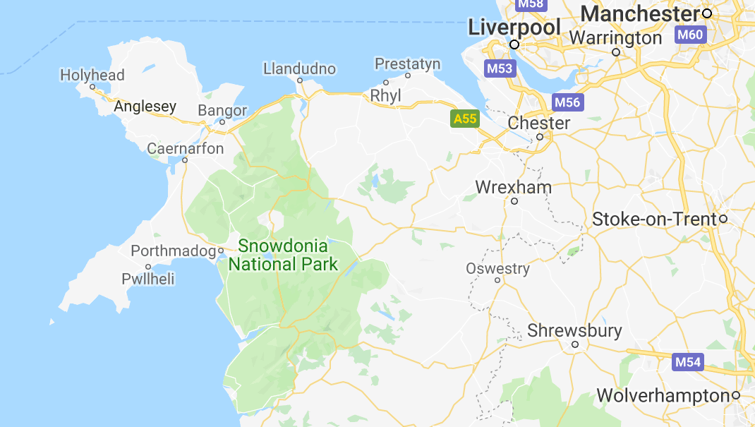

Figure 1: Map showing farm locations. Farms are numbered above the map.

# 2. The research of the project

## Artificial Insemination

100 semen straws were purchased for this project from a Dohne Merino Ram named Charlie, which were supplied by Murray River Genetics Ltd, Australia (see murrayrivergenetics.com). Dr Jean van Niekerk from Murray River Genetics processed the required export documentation and arranged the transport to the UK where Geraint Thomas from Animal Breeding Europe (see www.abreeds.co.uk) received the tank arranged delivery. Ian McDougall then conducted the artificial insemination (AI) for 25 Romney Ewes on each farm. The AI was successful with 17 ewes at Fferm Parlla Isaf and 18 at Blaen Cwm.

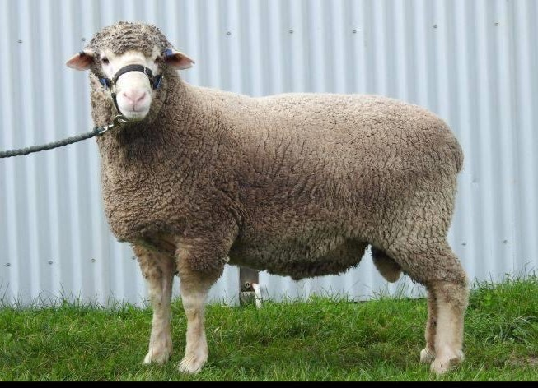

Figure 2: Charlie, the Dohne Merino Ram

## Lambing Vitality

#### Fferm Parlla Isaf

Approximately three weeks before lambing commenced the ewes were given fodder beet tops as a supplement. They were all lambed outside, grazed grass throughout lambing and had the fodder beet for about a week after lambing. This was the only supplement given to the ewes and lambs.

Figure 3: First Merino x Romney lambs to be born from AI.

The remaining eight Romney ewes that had unsuccessful AI were put with a Abermax ram and were used for the control group. They did not take to the ram on the next cycle after the AI attempt but were successful on a second attempt with the ram, therefore the control group lambs were approximately 34 days younger than the merino crosses.

All the Merino Romney crosses and the Abermax lambs from the control group were born without any assistance. They were very alert at birth and were up and suckling within minutes. The lambs grew well, no better or worse than any of the other lambs. By Christmas they were a good size and were sold in early January.

#### Blaen Cwm

From Scanning on the 20th of January 2022, all the ewes were put onto swedes until five days before lambing. After lambing they fed purely on grass alongside all the other ewes.

The lambs were born without assistance, they were alert and onto their feet and udder quickly. At approximately three weeks old, they had a slight scalding issue (inflammation between the hooves). They were treated with foot spray, and it cleared up quickly.



Figure 4: Average weights taken from a total of 28 lambs.

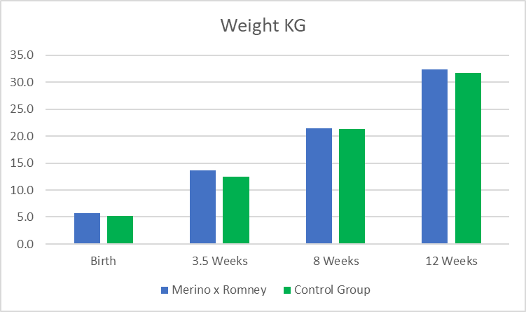

Figure 5: Average weights taken from a total of 28 lambs

Figures 4 and 5 show that the Merino cross Romney lambs have a very similar and marginally larger weight than the control group from birth to 12 weeks.

## Carcass Characteristics

Figures 6 and 7 show the weights taken from the eight lambs that had their wool tested. The merino cross lambs’ (blue columns on the graph) final live weight was 12% heavier than the control group (green columns). The average killing out wait for the merino cross was 45.3% and the control group was 45.8%. All four merino crosses achieved a carcass grading of O3L (fair, optimum fat) whereas three of the four lambs from the control group achieved a slightly better R3L (good, optimum fat), the fourth was O3L. Feedback from Blaen Cwm confirms that merino cross carcasses were impressive, and the meat was tasty.



Figure 6: Final live weight of eight lambs that had wool testing

Figure 7: Final live weight of eight lambs that had wool testing.

## Wool Characteristics

Two lambs from each group on each farm (eight in total) were shorn before going to the abattoir and side samples of wool were taken and sent to the Wool Testing Authority in Caernarfon.

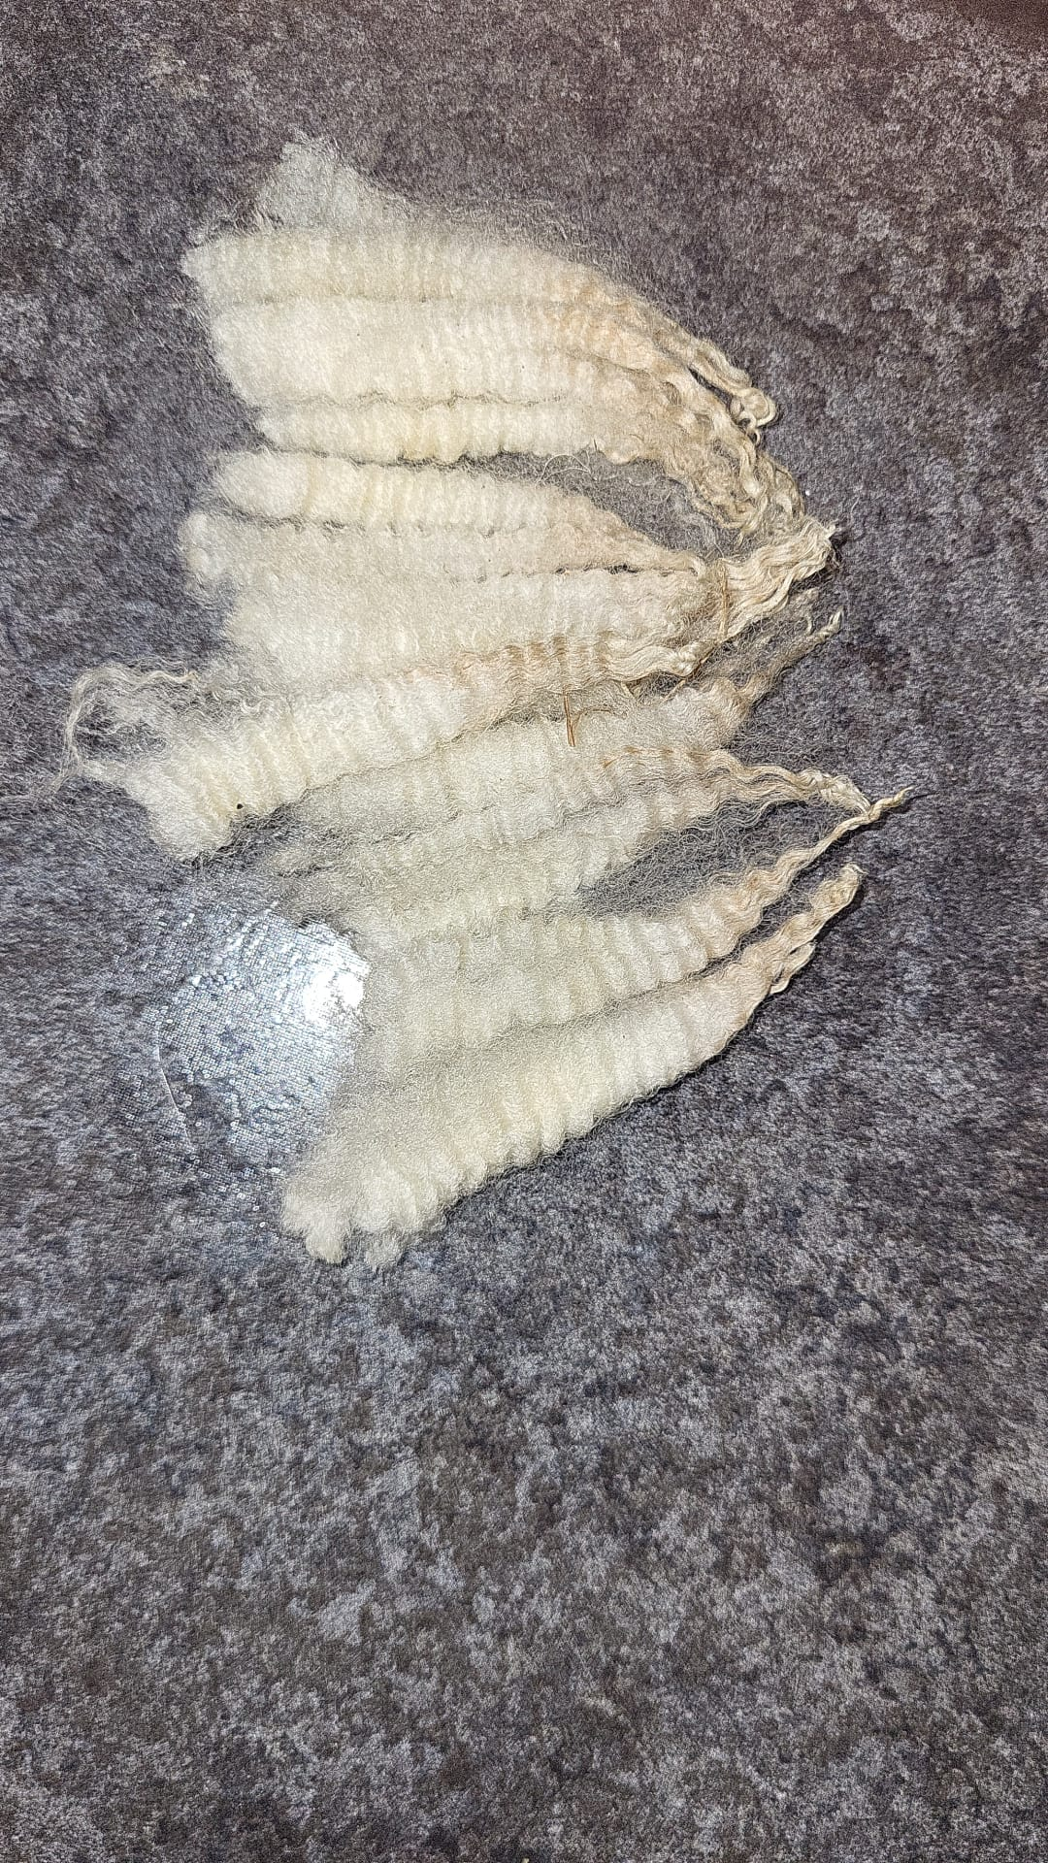

Figure 8: Merino Romney mid side wool samples sent to the WTA in Caernarfon



Figure 9: Wool micron tested by WTA Caernarfon

Figure 10: Wool micron tested by WTA Caernarfon

Figures 9 and 10 show a significant difference in the wool micron between the Merino crosses (blue columns) and the control group (green columns). The merino cross Romneys achieved an average of 22.1 Micron. The farmers were impressed with the measurements of both the merino cross and the Abermax crossed with a Romney ewe in the control group, considering both to be very positive. The micron measurements of the merino cross were particularly impressive as it was much finer than the farmers expected, especially considering they were only first cross lambs.

Figure 11: Merino x Romney wool at Fferm Parlla Isaf

# 3. Welfare

Prior to this project, the welfare of a merino cross in Wales was one of the main concerns due to the difference in environment compared to the merino’s native habitat. The purpose of the veterinary visits was to assess the welfare of the merino cross lambs in the UK environment.

Prior to the lambs being born the following issues were considered potential points of concern. The following comments have been gathered from Kate Pugh’s project summary vet report.

#### Lameness

Both flocks treated several lambs during the year for scald, but the incidence was no higher than in the commercial flocks.

#### Pneumonia

None of the lambs needed to be treated for pneumonia despite wet, windy, and snowy conditions.

#### Endoparasites

The faecal egg counts indicated when the lambs needed dosing for worms and fluke. Neither endoparasite proved problematic to treat or adversely affected the growth of the lambs.

#### Blowfly strike

The lambs were successfully treated with a jetter system to prevent blowfly strike. However, in the future a different solution would have to be found. The use of chemicals through a jetter system has been proven to promote resistance and has environmental implications. It is not recommended in the UK.

#### Losses

A few lambs did die over the year. The losses were minimal and were due to common illnesses also seen amongst commercial lambs.

The main issue that was found with the lambs was a high incidence of entropion (a turning in of the eyelid). Several lambs had to be treated for the condition and they did all eventually resolve. Unfortunately, this is a genetic condition, and it is therefore not advisable to use the same ram/ewe combination again.

Figure 12: Merino x Romney lambs outdoors in winter at Blaen Cwm Farm

Throughout the year the merino cross lambs proved that they could thrive in the UK environment without any welfare concerns. (Pugh, 2023).

# 4. Strategic relevance

Given the current economic climate it is now more important than ever for Welsh sheep farms to increase the value of their end product to counteract the continuous rise in costs. Once the merino-cross lambs retained for breeding have been shorn, and the fleeces valued, this project will hopefully prove that cross breeding with a more valuable fleece breed is a financially beneficial diversification (Pugh, 2023).

This project is already helping the farming community learn more about the introduction of new breeds to Wales. If the project is successfully implemented, then the door has been opened for other farmers to diversify by incorporating more new breeds on farms. The knowledge that is gathered from this project is being shared with the farming community in Wales and will develop a skills base in agriculture that is fit for purpose for the future world. This could increase the number of jobs available within agriculture sectors encouraging farmers to venture into this market to create further solutions for current agricultural challenges.

# 5. Collaborations

This project is bringing people from a variety of backgrounds to collaboratively trial an option for farm diversification. These stakeholders have been collaborating with each other during the project forging lasting relationships to solve common agricultural challenges. This collaboration of knowledge and combined skills of people involved is a major benefit to the project.

# 6. Dissemination

The strong group of people brought together for this project means that the outcomes have been disseminated to many different stakeholders interested in farm diversification and adding value.

It is recommended that sufficient resources are allocated to share the learnings from this project. This could be done by taking photos and creating videos to document the progress and provide articles for access to information gathered by this project.

# 7. Discussion

The following feedback has come from the farmers involved in this project.

* The project has been a success, there is no doubt. The lambs (lambing vitality and carcass characteristics) are no different and the wool is finer than expected.
* The only test left for this trial is to see what the Merino Romney ewes are like at breeding. This will test the cross breed further due to the stress and strain of rearing offspring.
* The Merino Romney ewes will be going to a ram with strong carcass characteristics in October. A texel, for example.
* A merino cross stud flock would need to be developed to further improve flock performance.
* The Merino Romney ewes will be sheared for their additional values fleeces.
* It would be good to increase the 17 Merino Romney Ewe flock at Fferm Parlla Isaf to approximately 300.
* There are approximately 50 merino semen straws left which will provide at least another year of AI.
* The cross breed does work, the weather has not affected them any differently than it would the native breeds. The merino cross has wintered well outside.

# 8. Summary

* This project has shown that a merino can be crossed with a native breed using AI and thrive outdoors in the North Wales environment.
* The Merino Romney crosses have achieved a multipurpose function of maintaining a good carcass and producing fine wool.
* The project has shown that the merino cross can be managed the same way as a native breed but with improved wool characteristics for added value.
* The trial has shown that there are no major welfare issues with farming a Merino Romney Cross in North Wales.

# 9. Conclusions

* There is scope for this project to evolve as it has uncovered many new avenues to be explored. It has laid the foundations for Merino Romney cross stud flock.
* The approach and methodology have worked well overall. The methodology has enabled lots of questions to be answered but also has raised some new questions for further developing this project.
* As Gwynedd upland sheep farming faces an uncertain future, this gives further importance to the work undertaken in this project. It has provided a better understanding of introducing new breeds to Gwynedd through AI, which is a big step forward.
* The farmers that participated in this project should look to benefit from funding provided if they wish to further develop their new breed flocks in the future.
* This approach could be replicated on other farms who are looking to introduce new breeds. The approach makes sense and one that can be replicated benefiting the wider industry.
* There is an opportunity for developing a brand from this new breed for adding value to blood lines, meat, and wool products.

# Acknowledgements

The project is indebted to the co-operation and dedication of:

* John and Gillian Williams, Fferm Parlla Isaf
* Arwel Bryn Jones, Fferm Blaen Cwm
* Ian McDougall, Veterinary Surgeon
* Kate Pugh, Veterinary Surgeon
* Dr Jean van Niekerk, Murray River Genetics
* Geraint Thomas, Animal Breeding Europe
* Dr Rob Elias, Director of Bio Composites
* Geraint Hughes and Meinir Jones - Lafan Consultancy

# References

Hunter, G. H. (2019, March). *Current State and Potential of the Wool Industry in Gwynedd*. Retrieved from Arloesi Gwynedd Wledig: https://www.arloesigwyneddwledig.cymru/wp-content/uploads/2019/05/1902-ADRODDIAD-Gwlan-LLAWN-SAES-Chwe19.pdf

Pugh, K. (2023, February). Merino Sheep Project Summary.