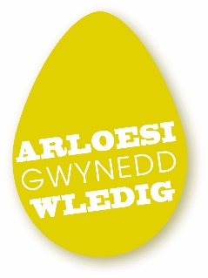
Gwynedd Piloting Fund
The Gwynedd Piloting Fund is targeted at community groups in Gwynedd, to enable them to pilot new activities that will contribute to their long-term sustainability and provide new services.
The money will be available for communities to carry out feasibility studies, activities, or to buy equipment to encourage them to become more sustainable.
e.g. Here are the kind of things that would be applicable.
- Feasibility study on new use for a building owned by a third sector organisation
- Business plan for a new community-owned enterprise eg bunker accommodation
- Pilot saving or energy use equipment eg SMART energy meters.
- Pilot new methods of generating income eg 3D printers, cinema equipment

This fund will be available to rural community groups in Gwynedd to apply to Arloesi Gwynedd Wledig for funding of up to £10,000. Assistance is available for up to 70% of the required sum, up to a total of £10,000 per application.
Thirty per cent of the "match funding" must be provided on a cash basis (that is, we cannot consider contributions in kind, such as an individual's time). Also, "match funding" should not be related to other European funding or funding from the Welsh Government.
Groups will be required to submit an application form detailing what they would be piloting and what support they need to make progress.
You will need to refer to the "Gwynedd LDS Themes" document in answer to question 8. The Local Development Strategy outlines the priorities of Arloesi Gwynedd Wledig (AGW), the name given to the LEADER programme in Gwynedd, over the 6 years, and there will be a need to tie up the priorities with the submitted application. Arloesi Gwynedd Wledig officers will help complete questions 9 and 12 on the application form.
The closing date for the next round of the fund is the 25th of January, 2019.
For an application pack or more information, you can contact Rhys Gwilym on 01766 514057 or rhys@mentermon.com

